
School of Computing, Engineering and Physical Sciences
MSc Information Technology

Project Title: E-commerce Product Recommendation Using Machine Learning Approach
By
Name: Nabin Malla
Banner Id: B01750653
Date of submission: 2026-04-23
Supervisor: Abida Aslam
Moderator: Abel Usoro



DECLARATION OF ORIGINALITY

I declare that this is an original study based on my own
work and that I have not submitted it for any other
course or degree.

Signature: Nabin Malla

Appendix V: Library Release Form



Library Form to Accompany MSc Project

Surname: Malla
First Name: Nabin
Banner No: B01750653
Course Code: COMP11128
Course Title: MSc IT with Project Management
Project Supervisor: Abida Aslam
Project Title: E-commerce Product Recommendation Using Machine Learning Approach
Session: 2025/26 T2 , Date of Submission:2026-04-23
Signature: Nabin Malla

Table of Contents
1 Introduction 5
2 Literature Review 6
2.1 Machine Learning in E-commerce Recommendation Systems: 6
2.2 Customer Sentiment Analysis in E-commerce: 6
2.3 Consumer Behavior and Purchase Prediction: 6
2.4 Optimizing E-commerce Systems Using Hybrid Models: 7
2.5 Summary and Literature Gap: 7
3 Results & Discussions 7
3.1 Monthly Revenue (Completed vs. Cancelled Invoices) 7
3.2 Quantity vs. Revenue Relationship 8
3.3 Top 10 Customers by Order Frequency 9
3.4 Average Order Value (AOV) by Day of Week 10
3.5 Transaction Feature Correlation Matrix 11
3.6 Transaction Market Share: UK vs. International 13
3.7 Target Distribution: Before and After Oversampling 14
3.8 Model Performance Results 14
3.9 Model Performance Comparison 15
4 Critical Reflection 17
5 Conclusion 17
5.1 Summary of Findings 17
5.2 Conclusion 18
References: 19
Appendix 20

Table of Figures
Figure 3.1: Monthly Revenue (Completed vs. Cancelled Invoices) 8
Figure 3.2: Quantity vs. Revenue Relationship 9
Figure 3.3: Top 10 Customers by Order Frequency 10
Figure 3.4: Average Order Value (AOV) by Day of Week 11
Figure 3.5: Transaction Feature Correlation Matrix 12
Figure 3.6: Transaction Market Share: UK vs. International 13
Figure 3.7: Target Distribution: Before and After Oversampling 14
Figure 3.8: Model Performance Results 15
Figure 3.9: Model Performance Comparison 16

Introduction
The application of machine learning in e-commerce product recommendation systems has become a crucial tool for enhancing customer experience, boosting sales, and improving personalization. As online retail becomes increasingly competitive, businesses must leverage data and predictive models to provide customers with tailored product suggestions that align with their preferences and behaviors. The focus of this project was to develop and evaluate various machine learning models for e-commerce recommendation tasks, aiming to identify the most effective algorithms for accurately predicting customer preferences.
This report focuses on the implementation and evaluation of additional machine learning models, particularly K-Nearest Neighbors (KNN), AdaBoost, and Gradient Boosting, which were tested to determine their effectiveness in the recommendation system. The evaluation of these models involved assessing their performance across key metrics such as accuracy, precision, recall, and F1-score, enabling a clear comparison of how each model performed under the same conditions. The goal was to explore the potential of these models to improve the accuracy and personalization of recommendations.
The contribution in this phase was crucial in expanding the model selection beyond the traditional approaches, providing deeper insights into how different algorithms perform on e-commerce data. By testing these additional models and analyzing their results, valuable insights were gained into their strengths, weaknesses, and suitability for recommendation tasks. This report outlines the implementation, results, and findings from these models, contributing to the broader understanding of machine learning applications in e-commerce and product recommendation systems.

Literature Review

Machine Learning in E-commerce Recommendation Systems:
Machine learning techniques have been widely adopted to improve product recommendations on e-commerce platforms. Huang (2022) explores the use of collaborative filtering and matrix factorization in generating personalized product suggestions. These machine learning techniques utilize user-item interaction matrices to predict user preferences based on historical data. Huang emphasizes the potential of machine learning models in overcoming the cold-start problem, especially when incorporating demographic and behavioral data. Additionally, Li (2024) investigates the combination of different machine learning models to further enhance recommendation accuracy. By applying multimodal data, such as user interaction logs, product details, and user demographics, Li's study demonstrates how machine learning can combine these data sources to offer more relevant and dynamic product recommendations. These insights reveal that hybrid machine learning models, which incorporate multiple data sources, are essential in tackling the challenges faced by traditional recommendation systems, especially in dynamic e-commerce environments.

Customer Sentiment Analysis in E-commerce:
Understanding customer sentiment is crucial in improving product recommendations by factoring in subjective user opinions. Huang et al. (2023) review various machine learning-based sentiment analysis techniques used in e-commerce platforms to analyze customer reviews. They highlight the effectiveness of natural language processing (NLP) techniques, such as sentiment classification and opinion mining, in extracting meaningful insights from text-based customer feedback. Hossain et al. (2022) extend this approach by utilizing machine learning classifiers like support vector machines (SVM) and random forests to analyze customer sentiment in product reviews. These insights can be integrated into recommendation systems to refine product suggestions based on positive or negative sentiments associated with products. The integration of sentiment analysis into product recommendation systems helps capture the emotional preferences of users, enabling more personalized and relevant product suggestions. This integration can further enhance user engagement and satisfaction on e-commerce platforms.

Consumer Behavior and Purchase Prediction:
Predicting consumer behavior is essential for developing effective product recommendation systems. Trivedi et al. (2024) explore the use of machine learning models to predict purchasing decisions based on consumer browsing patterns and historical data. By applying decision trees and random forests, their research identifies key factors influencing a consumer's likelihood to make a purchase. These models help understand user preferences and predict which products are most likely to interest individual customers. Integrating these machine learning techniques into a recommendation system allows platforms to suggest products that align with the predicted preferences of users. This approach addresses the limitations of traditional recommendation methods, which often fail to account for the dynamic nature of consumer behavior. By considering factors such as past purchases, browsing history, and product interaction, machine learning models provide more personalized recommendations, improving conversion rates and customer Satisfaction on E-commerce Platforms:

Optimizing E-commerce Systems Using Hybrid Models:
Hybrid machine learning models have proven to be effective in optimizing recommendation systems and improving prediction accuracy. Alghazzawi et al. (2023) introduce the ERF-XGB model, which combines ensemble random forest and XGBoost algorithms to improve the prediction and classification accuracy of e-commerce product reviews. By combining these models, their system leverages the strengths of both random forests and gradient boosting, ensuring better handling of complex data and achieving higher predictive accuracy. Similarly, Anand et al. (2023) propose a hybrid model combining image-based features and user preference data for personalized product recommendations in e-commerce. This approach highlights the importance of using hybrid machine learning techniques to handle multiple data types, such as images and behavioral data, for more accurate recommendations. The integration of these diverse models not only improves recommendation accuracy but also enhances the scalability and adaptability of recommendation systems, enabling real-time, personalized product suggestions.

Summary and Literature Gap:
The literature reveals significant advancements in using machine learning for e-commerce recommendation systems, including collaborative filtering, hybrid models, and sentiment analysis, which enhance personalization and recommendation accuracy. However, several gaps remain. Data quality is a major issue, as real-world datasets often contain missing, noisy, or inconsistent data, which degrades model performance. Additionally, overfitting occurs when models are trained on limited or complex data, resulting in poor generalization to unseen data. Class imbalance also affects recommendation systems, where some products or categories are overrepresented, leading to biased recommendations. Moreover, bias in data—such as gender, age, or location bias—can skew results and reduce fairness in recommendations. Addressing these gaps by improving data handling, mitigating overfitting, and ensuring fairness and balance in training data is essential for enhancing the accuracy and reliability of recommendation systems.

Results & Discussions

Monthly Revenue (Completed vs. Cancelled Invoices)
The Figure 3.1 displays a bar chart comparing the monthly revenue from completed invoices versus cancelled invoices. The x-axis represents the months from January (1) to December (12), while the y-axis shows the revenue generated during each month. The chart is divided into two parts: the blue bars represent the revenue from completed invoices, while the red bars show the revenue from cancelled invoices. The blue bars are consistently much larger than the red bars, indicating that completed invoices contribute significantly more to the revenue compared to cancelled invoices.
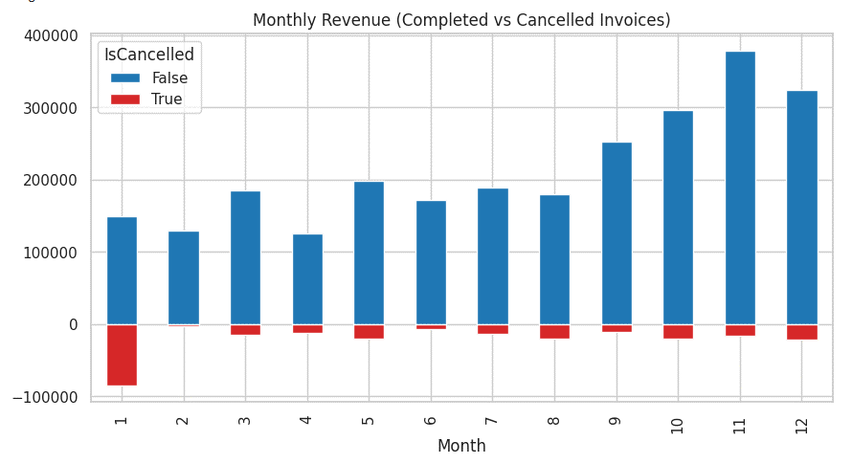
Figure 3.1: Monthly Revenue (Completed vs. Cancelled Invoices)
As shown in Figure 3.1, November (Month 11) and December (Month 12) have the highest revenue from completed invoices, with November exceeding 400,000 units. Despite the significant revenue from completed invoices, there is also a noticeable amount of revenue loss due to cancellations, especially in January (Month 1), where the red bar representing cancelled invoices is relatively large. However, throughout the rest of the year, the number of cancelled invoices remains much smaller in comparison to completed invoices. The chart shows that cancellations occur across all months, but they represent a small portion of the overall revenue.
This analysis of completed versus cancelled invoices is important for businesses to identify patterns in cancellations and assess their impact on overall revenue. The company can use this insight to implement strategies to reduce cancellations, improve customer retention, and enhance their overall revenue performance. Understanding the trends in completed and cancelled invoices also helps in forecasting future revenue and planning for potential losses due to cancellations.

Quantity vs. Revenue Relationship
The figure 3.2 shows a scatter plot that illustrates the relationship between Quantity and Revenue. The x-axis represents the quantity of items sold, while the y-axis shows the corresponding revenue generated. The plot highlights a clear positive correlation between quantity and revenue, where the revenue increases as the quantity of items sold rises. However, the plot also reveals a dense clustering of data points around low quantities and low revenue, indicating that many transactions involve smaller quantities, resulting in lower revenue.
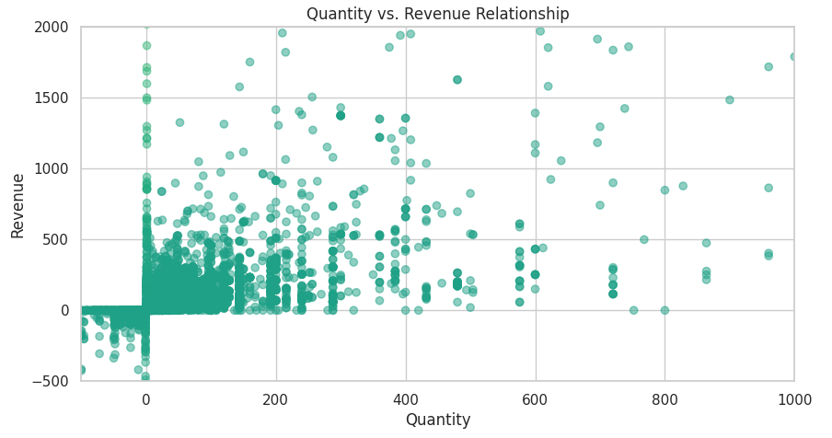
Figure 3.2: Quantity vs. Revenue Relationship
As seen in Figure 3.2, most of the data points are clustered near the origin, with quantities between 0 and 100 and corresponding revenue values close to 0. As the quantity increases, the revenue also rises, with fewer data points reaching the higher end of both axes. There is also a noticeable tail where revenue increases sharply with quantities greater than 200. This suggests that higher quantities tend to result in larger revenue, but they are less frequent. The scatter plot provides valuable insight into how revenue is affected by the number of items sold, with smaller transactions generally leading to lower revenue and larger transactions generating more significant revenue.
Understanding the relationship between quantity and revenue is crucial for businesses to optimize their pricing and sales strategies. By analyzing how these two variables interact, businesses can better predict revenue based on quantity sold and adjust their inventory, marketing efforts, and sales forecasts accordingly. This analysis also helps businesses identify the most profitable sales ranges and determine the optimal quantity thresholds that maximize revenue.

Top 10 Customers by Order Frequency
The figure 3.3 shows a horizontal bar chart representing the top 10 customers by order frequency. The x-axis indicates the number of orders placed by each customer, while the y-axis lists the CustomerID of the top customers. The chart reveals that CustomerID 17841 has the highest order frequency, with more than 1,800 orders placed. Other top customers, such as CustomerID 14911 and CustomerID 12748, also have high order frequencies, each with over 1,000 orders. The data suggests that a small number of customers are responsible for a large share of the total orders, highlighting the importance of customer loyalty and retention strategies.
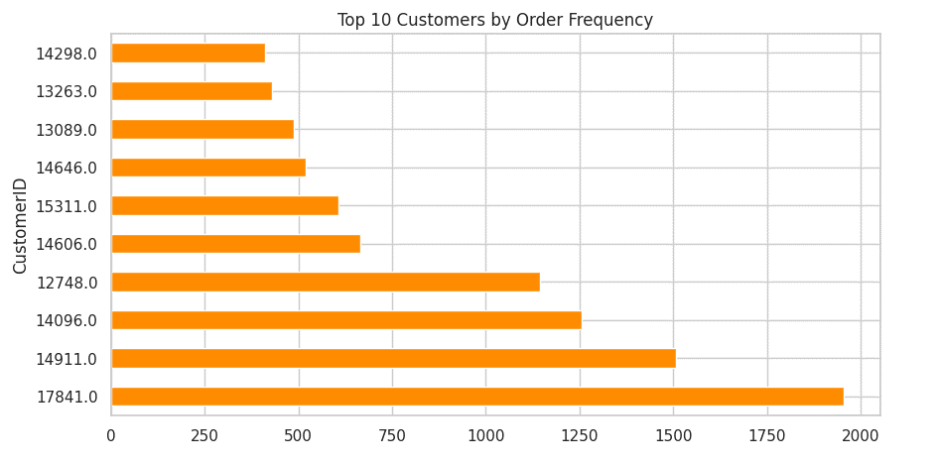
Figure 3.3: Top 10 Customers by Order Frequency
As shown in Figure 3.3, the majority of the top customers exhibit a significant number of orders, but there is a noticeable drop-off after the first few customers. The chart indicates that most customers in the top 10 place several hundred orders, with the largest contributors reaching well over 1,000. This implies that a concentrated group of customers consistently drive sales, emphasizing the need for businesses to prioritize these high-value customers for personalized marketing, loyalty programs, and tailored offerings to encourage continued engagement and repeat purchases.
The chart also provides useful insights into customer behavior, which can be leveraged for improving business strategies. Understanding the order frequency of top customers helps businesses make data-driven decisions regarding inventory management, promotional offers, and customer support. This insight into the most frequent customers allows businesses to maximize their focus on retaining these key individuals while also considering strategies for increasing the order frequency of less frequent customers.

Average Order Value (AOV) by Day of Week
The figure 3.4 illustrates the Average Order Value (AOV) by day of the week. The x-axis represents the days from Monday to Sunday, while the y-axis shows the average order value for each respective day. The chart reveals a distinct pattern, with the AOV reaching its highest point on Thursday, peaking just above 20. The AOV begins at a lower level on Monday and Tuesday, gradually increasing towards Thursday before experiencing a sharp drop on Friday and Sunday. The lowest AOV is seen on Sunday, which may be due to fewer transactions or smaller order sizes during the weekend.
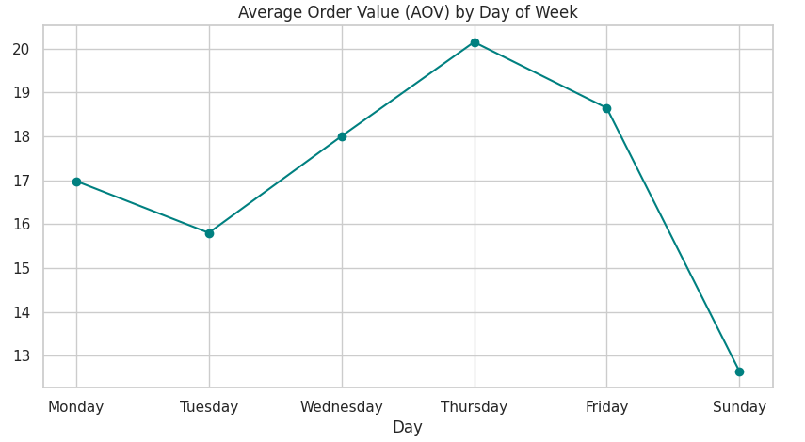
Figure 3.4: Average Order Value (AOV) by Day of Week
As shown in Figure 3.4, Thursday stands out with the highest AOV, indicating that customers tend to make larger purchases toward the end of the week, potentially in anticipation of weekend events or promotions. Friday shows a drop in AOV, and Sunday follows with the lowest AOV, which could reflect a slower shopping period or smaller orders as the week wraps up. This suggests that consumer spending behavior varies throughout the week, with higher-value orders typically occurring mid-week.
Understanding these trends allows businesses to optimize their pricing, promotions, and inventory strategies. By focusing on high-revenue days such as Thursday, businesses can plan targeted promotions, offer discounts, or introduce new products that encourage higher-value purchases. Meanwhile, understanding the lower AOV on Sunday and Friday could help businesses adjust their strategies to boost sales on these days, such as through flash sales or product bundling.

Transaction Feature Correlation Matrix
The figure 3.5 presents a heatmap that visualizes the correlation matrix between various transaction features: Quantity, UnitPrice, Revenue, Month, and Hour. The correlation values are shown in the cells of the matrix, with color intensity indicating the strength of the correlation (red represents high correlation, blue represents low correlation). The color scale on the right shows the range from 0 to 1, where 1 indicates a perfect correlation, and values close to 0 suggest weak or no correlation between the respective features.
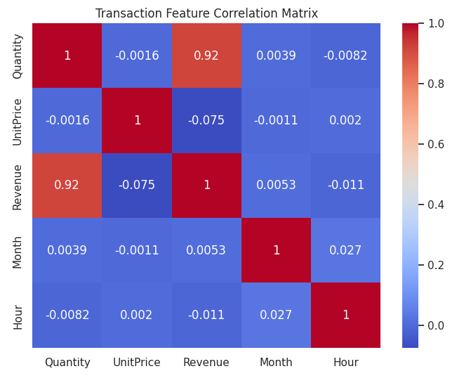
Figure 3.5: Transaction Feature Correlation Matrix
As shown in Figure 3.5, the most prominent correlation is between Quantity and Revenue, with a value of 0.92, indicating a very strong positive correlation. This suggests that as the quantity of items sold increases, the revenue also increases significantly, which is expected in e-commerce transactions. On the other hand, UnitPrice shows a very weak correlation with Quantity (-0.0016) and Revenue (-0.075), indicating that while unit price may have some influence on revenue, its effect is not as strong as quantity. Month and Hour show weak correlations with other features, with values around 0.03 to 0.05, suggesting that time-related factors like the month or hour of the transaction have minimal impact on revenue or quantity sold.
This correlation matrix provides valuable insights for businesses looking to understand the relationships between different transaction features. The strong correlation between Quantity and Revenue can help businesses focus on increasing the volume of items sold to boost sales. The weak correlation between UnitPrice and the other features suggests that pricing strategies may not be as impactful as increasing sales volume, although pricing still plays a role. Understanding these relationships can help businesses refine their strategies, optimize pricing, and focus on increasing the quantity of sales for higher revenue generation.

Transaction Market Share: UK vs. International
The figure 3.6 presents a pie chart showing the market share of transactions between the UK and International markets. The chart reveals a dominant share for the UK, which accounts for 91.5% of the transactions. In contrast, the International market contributes only 8.5% of the total transaction volume. This disparity suggests that the majority of transactions are occurring within the UK, while international transactions represent a smaller portion of the overall sales.
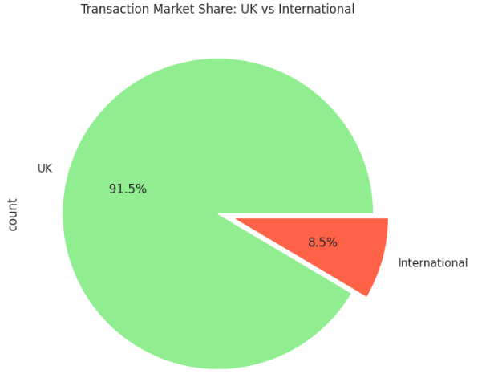
Figure 3.6: Transaction Market Share: UK vs. International
As shown in Figure 3.6, the UK market is the clear leader in terms of transaction volume, with a vast majority of the transactions occurring within the country. This could indicate a higher concentration of customers, demand, or product offerings tailored to the UK market. The International market, although significantly smaller in comparison, still contributes a meaningful portion of transactions. This could represent customers from different countries or regions, and understanding this segment could provide opportunities for businesses to expand and tailor marketing strategies to attract more international customers.
The data emphasizes the importance of focusing on the domestic market, while also recognizing the potential for growth in international sales. For businesses looking to expand, strategies to capture a larger share of the international market could involve targeted marketing, optimizing shipping processes, or expanding product availability in global markets. The insights provided by this chart help guide decision-making for both domestic and international market strategies.

Target Distribution: Before and After Oversampling
The figure 3.7 shows a comparison of the target distribution for the IsInternational variable before and after oversampling. The left chart, Target Distribution: Before Oversampling, shows a highly imbalanced distribution, where IsInternational = 0 (non-international transactions) significantly outweighs IsInternational = 1 (international transactions). The blue bar representing non-international transactions is far larger, while the purple bar representing international transactions is much smaller, indicating a clear imbalance in the dataset.
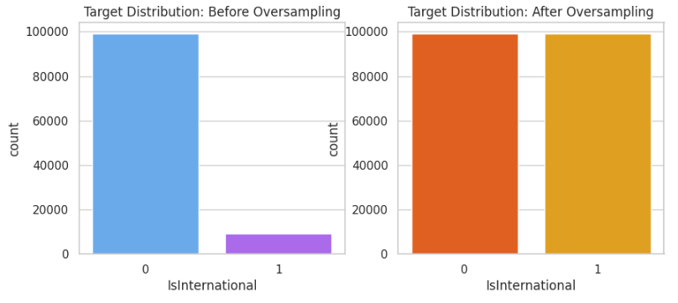
Figure 3.7: Target Distribution: Before and After Oversampling
The right chart, Target Distribution: After Oversampling, illustrates the effect of the oversampling technique applied to the minority class (IsInternational = 1). After oversampling, both categories (0 for non-international and 1 for international) have approximately the same number of instances, shown by the orange and yellow bars being of equal length. This adjustment ensures that the dataset is balanced, with both classes having an equal representation, which is crucial for training machine learning models without bias towards the majority class.
The oversampling of the minority class is an important technique to address class imbalance in datasets, as it helps ensure that models do not become biased towards predicting the majority class. By balancing the dataset, machine learning models can learn to classify both non-international and international transactions more effectively, improving the performance of the recommendation system.

Model Performance Results
Figure 3.8 shows the performance results of three machine learning models—KNN (K-Nearest Neighbors), AdaBoost, and Gradient Boosting—evaluated based on accuracy, precision, recall, and F1-score. As presented in the table, KNN achieved the highest accuracy of 0.759116, but its precision was significantly lower at 0.199061. Its recall was relatively higher at 0.609055, resulting in an F1-score of 0.300054. This suggests that while KNN has a decent accuracy, it may struggle with false positives and is not well balanced in terms of precision and recall.
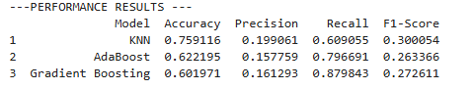
Figure 3.8: Model Performance Results
In comparison, AdaBoost has a slightly lower accuracy of 0.622195, but it performs better in terms of recall (0.796691), making it more sensitive to identifying true positives. However, its precision is still low at 0.157759, leading to a modest F1-score of 0.263366. Gradient Boosting, which also showed a lower accuracy of 0.601971, had a relatively higher recall of 0.879843, but its precision and F1-score were still not optimal.
These results highlight the trade-offs between precision and recall in these models. KNN has a higher accuracy but a less balanced performance, whereas AdaBoost and Gradient Boosting provide better recall, which is often desired in imbalanced classification tasks like recommendation systems. The choice of the most suitable model depends on the importance of precision versus recall in the context of e-commerce product recommendation tasks.

Model Performance Comparison
Figure 3.9 presents a bar chart comparing the performance of three machine learning models: KNN (K-Nearest Neighbors), AdaBoost, and Gradient Boosting. The chart compares the models across four key evaluation metrics: Accuracy, Precision, Recall, and F1-Score. The x-axis represents the metrics, and the y-axis shows the score for each metric. The chart shows that KNN has the highest accuracy, but Gradient Boosting performs significantly better in recall, achieving the highest value among the three models. AdaBoost falls in between, showing moderate performance in all metrics.
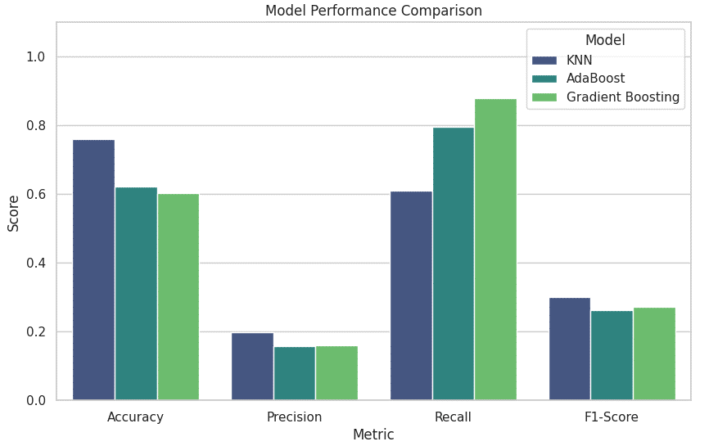
Figure 3.9: Model Performance Comparison
As shown in Figure 3.9, KNN excels in accuracy but has a low precision and recall, indicating that while it predicts correctly more often, it struggles with identifying true positives (low recall). AdaBoost and Gradient Boosting both demonstrate better recall, especially Gradient Boosting, which excels at capturing positive instances, though it lags behind KNN in accuracy. The performance of AdaBoost and Gradient Boosting on precision and F1-score is balanced, indicating that these models provide a more comprehensive and robust performance for e-commerce recommendation tasks.
The comparison highlights that Gradient Boosting is the best model for recall, making it a strong candidate for tasks where correctly identifying positive cases (such as identifying relevant products for recommendations) is crucial. On the other hand, KNN shows a trade-off, with better accuracy but poor recall and precision, making it less suitable for tasks where both correct identification and relevance are important. This comparison provides useful insights for selecting the most appropriate model depending on the specific needs of the recommendation system.

Critical Reflection
This study demonstrates the importance of choosing the right machine learning model for e-commerce product recommendation systems. The comparative analysis of KNN (K-Nearest Neighbors), AdaBoost, and Gradient Boosting revealed significant insights into the trade-offs between different performance metrics. KNN performed well in terms of accuracy but struggled with precision and recall, which highlighted its limitations in capturing complex relationships within e-commerce data. On the other hand, AdaBoost and Gradient Boosting offered better recall, making them more suitable for tasks where identifying relevant products for customers is critical. These results suggest that ensemble methods like AdaBoost and Gradient Boosting are more appropriate for recommendation systems that require balancing precision and recall for personalized product recommendations.
However, the study also has its limitations. For instance, it focused only on a narrow range of models, and it did not incorporate more advanced techniques like deep learning or hybrid models, which have shown promising results in similar tasks. Incorporating models such as neural networks or collaborative filtering could have provided a more comprehensive understanding of how different algorithms perform in the context of e-commerce recommendations. Additionally, the study was based on a single dataset, limiting the generalizability of the findings. Future work should involve testing these models on a more diverse set of datasets from various e-commerce platforms to understand their performance in different real-world contexts.
Despite these limitations, the study's findings emphasize the critical role of recall in recommendation systems, where the goal is to suggest the most relevant products to users. Gradient Boosting, in particular, showed a significant advantage in recall, making it the ideal model for tasks requiring accurate product recommendations. The insights gained from this analysis are valuable for future research and model development, offering a solid foundation for further exploration into advanced machine learning techniques for e-commerce.

Conclusion

Summary of Findings
This study focused on evaluating various machine learning models for e-commerce product recommendation systems, with a specific focus on KNN (K-Nearest Neighbors), AdaBoost, and Gradient Boosting. The performance of these models was assessed across key metrics: accuracy, precision, recall, and F1-score. The findings revealed that KNN had the highest accuracy but performed poorly in recall and precision, indicating it was effective at predicting overall correctness but struggled with identifying relevant products. AdaBoost showed a more balanced performance across all metrics, while Gradient Boosting emerged as the best model for recall, making it ideal for tasks where identifying positive instances (such as relevant products) is critical for effective recommendations.
The results highlighted that Gradient Boosting outperformed the other models in recall, suggesting it is particularly well-suited for product recommendation tasks that prioritize relevance and capturing true positive instances. On the other hand, KNN demonstrated a trade-off, where high accuracy did not correlate with high recall or precision. This points to the need for a more comprehensive evaluation in recommendation systems, where precision and recall need to be balanced for optimal performance.
Additionally, the study emphasized the importance of using appropriate models based on specific goals in recommendation systems. Gradient Boosting and AdaBoost offered better overall performance, especially in handling the complexity of e-commerce data and producing more accurate recommendations. These findings are significant for selecting models in real-world applications where both prediction accuracy and relevance are essential for improving customer experience.

Conclusion
In conclusion, this study successfully highlighted the strengths and weaknesses of three popular machine learning models—KNN, AdaBoost, and Gradient Boosting—for e-commerce product recommendation tasks. The comparative analysis revealed that Gradient Boosting performed best in terms of recall, which is crucial for recommendation systems where identifying the most relevant products is key. Although KNN achieved the highest accuracy, its poor performance in recall and precision indicated that it is not as suitable for tasks requiring the identification of relevant items. AdaBoost showed a more balanced performance but still did not match Gradient Boosting in its ability to capture positive instances.
The study’s findings emphasize the importance of balancing multiple metrics, such as accuracy, precision, and recall, when selecting models for recommendation systems. Gradient Boosting, with its superior recall, emerged as the most effective model for e-commerce recommendations, while simpler models like KNN and AdaBoost demonstrated limitations in comparison. These results suggest that ensemble models, particularly Gradient Boosting, are more appropriate for e-commerce recommendation systems that need to effectively capture both accuracy and relevance.
Ultimately, the study provides valuable insights into the selection of machine learning models for e-commerce applications, where customer satisfaction and product relevance are essential. Further research could explore the incorporation of more advanced techniques, such as deep learning and collaborative filtering, to enhance recommendation systems and further optimize performance. The findings serve as a foundation for future work in machine learning for e-commerce, contributing to the development of more accurate and personalized product recommendation systems.

References:
Alghazzawi, D.M., Alquraishee, A.G.A., Badri, S.K. and Hasan, S.H., 2023. ERF-XGB: Ensemble random forest-based XG boost for accurate prediction and classification of e-commerce product review. Sustainability, 15(9), p.7076. https://www.mdpi.com/2071-1050/15/9/7076
Almuqren, L., Alruwais, N., Alhashmi, A.A., Alzahrani, I.R., Salih, N., Assiri, M. and Shankar, K., 2024. WSN-assisted consumer purchasing power prediction via barracuda swarm optimization-driven deep learning for E-commerce systems. IEEE Transactions on Consumer Electronics, 70(1), pp.1694-1701. https://ieeexplore.ieee.org/abstract/document/10477271/
Anand, R., Nirmal, V., Chauhan, Y. and Sharma, T., 2023, March. An image-based deep learning approach for personalized outfit selection. In 2023 10th International Conference on Computing for Sustainable Global Development (INDIACom) (pp. 1050-1054). IEEE. https://ieeexplore.ieee.org/abstract/document/10112282/
Hossain, M.J., Joy, D.D., Das, S. and Mustafa, R., 2022, February. Sentiment analysis on reviews of e-commerce sites using machine learning algorithms. In 2022 International Conference on Innovations in Science, Engineering and Technology (ICISET) (pp. 522-527). IEEE. https://ieeexplore.ieee.org/abstract/document/9775846/
Huang, G., 2022, April. E-commerce intelligent recommendation system based on deep learning. In 2022 IEEE Asia-Pacific Conference on Image Processing, Electronics and Computers (IPEC) (pp. 1154-1157). IEEE. https://ieeexplore.ieee.org/abstract/document/9777500/
Huang, H., Zavareh, A.A. and Mustafa, M.B., 2023. Sentiment analysis in e-commerce platforms: A review of current techniques and future directions. Ieee Access, 11, pp.90367-90382. https://ieeexplore.ieee.org/abstract/document/10225509/
Li, S., 2024, September. Harnessing multimodal data and mult-recall strategies for enhanced product recommendation in e-commerce. In 2024 4th International Conference on Computer Systems (ICCS) (pp. 181-185). IEEE. https://ieeexplore.ieee.org/abstract/document/10795856/
Mutemi, A. and Bacao, F., 2024. E-commerce fraud detection based on machine learning techniques: Systematic literature review. Big Data Mining and Analytics, 7(2), pp.419-444. https://ieeexplore.ieee.org/abstract/document/10506811/
Shobana, J., Gangadhar, C., Arora, R.K., Renjith, P.N., Bamini, J. and devidas Chincholkar, Y., 2023. E-commerce customer churn prevention using machine learning-based business intelligence strategy. Measurement: Sensors, 27, p.100728. https://www.sciencedirect.com/science/article/pii/S2665917423000648
Trivedi, S.K., Patra, P., Srivastava, P.R., Zhang, J.Z. and Zheng, L.J., 2024. What prompts consumers to purchase online? A machine learning approach. Electronic Commerce Research, 24(4), pp.2953-2989. https://link.springer.com/article/10.1007/s10660-022-09624-x

Appendix
